1. Writing symbols or alphabets in English language are different from speech sounds.
2. There are 26 alphabets in English, out of which 5 are vowels and rest are consonants.
3. There are 20 vowel sounds and 24 consonant sounds in English.
4. The exhaling flow of air is responsible for the production of speech sounds.
5. In the vowel sounds ‘i’ and ‘ii’, the former is a short vowel, while the latter is a long vowel.
6. A speech sound is written between two slashes/slant lines. The vowel sound present in the word ‘cup’ is /u/.
7. The phonetic nature of the consonants in English language is depicted below

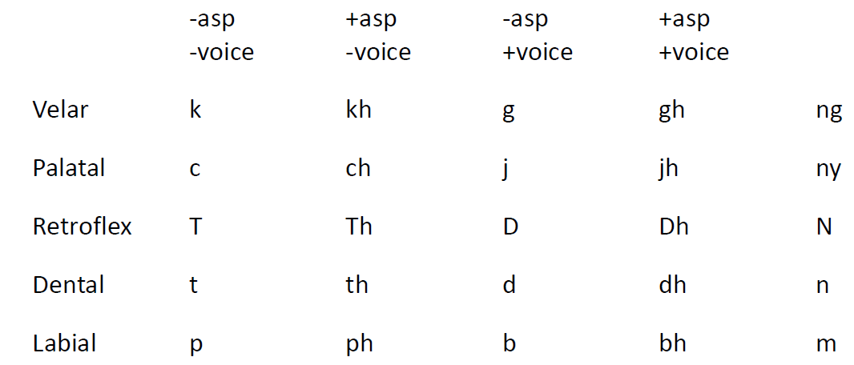

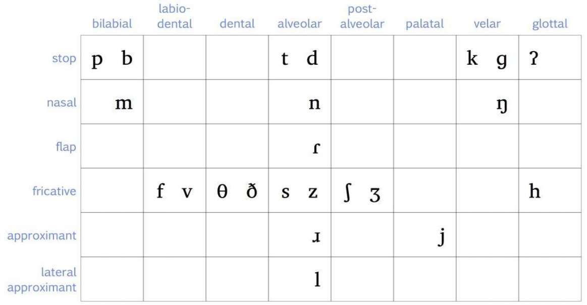

1. The sound /f/ is a fricative labio-dental sound.
2. The sound /k/ is a velar sound.
3. The sound /h/ is a fricative glottal sound.
4. The sound /m/ is a nasal bilabial sound.
5. Total closure of mouth/airflow leads to the production of stop sounds.
6. Two approaches to listening are bottom-up and top-down approach. Beginners start with the former, whereas experts use the latter.
7. Bottom-up approach has the following steps.
   1. Recognize words and clauses
   2. Recognize key words
   3. Recognize key transition words/phrases in a discourse/speech
   4. Recognize grammatical relationships between key words in the sentence
   5. Recognize the order in which words occur in a sentence
8. Top-up approach has the following steps.
   1. use key words to construct the ideas involved in a conversation/discourse
   2. infer the setting for a text
   3. infer the role of the participants and their goals
   4. infer cause and effect relationship
   5. guess unsaid details of a situation/ guess
   6. guess/anticipate questions related to a given topic
9. Listening involves active processing, reformulation and revision.